**Paraguay Diagnosis**

Unlike the rest of Latin America and the Caribbean countries, the data for Paraguay was taken in 2021. Therefore, neither questions from the Expanded GPP nor the Caribbean corruption questionnaire are available for this country because these questions began to be asked in 2022. As a result, for the current report for Paraguay, we only have 9 of 16 graphs; the status of the data availableness for each chart is shown below.

**Section 1**

**Authoritarianism**

|  |  |
| --- | --- |
| **Chart** | **Status** |
| **Chart 1: Perceptions About Authoritarian Behaviors** | **No data available** |
| **Chart 2: Perceptions of Authoritarian Behaviors by Support for the Governing Party** | **No data available** |
| **Chart 3: Perceptions About Authoritarian Behaviors** | **No data available for some figures** |

**Fundamental Freedoms**

|  |  |
| --- | --- |
| **Chart** | **Status** |
| **Chart 4: Respect to the Fundamental Freedoms in Latin-American and Andean**  **Countries** | **All the data are available** |

**Accountability**

|  |  |
| --- | --- |
| **Chart** | **Status** |
| **Chart 5: Perceptions of Accountability in the Region Over Time** | **All the data are available** |

**Section 2**

**Corruption and Trust**

|  |  |
| --- | --- |
| **Chart** | **Status** |
| **Chart 6.1: Trust in Community** | **All the data are available** |
| **Chart 6.2: Perceptions of Corruption and Levels of Trust by Institution** | **All the data are available** |
| **Chart 7: Perceptions of Corruption in the Region, by Institution** | **No data available for some figures** |
| **Chart 8: Attitudes Towards Corrupt Behaviors in the Region** | **No data available** |

**Bribery Victimization**

|  |  |
| --- | --- |
| **Chart** | **Status** |
| **Chart 9: Bribery Victimization in Colombia and Regional Peer Countries** | **All the data are available** |

**Section 3**

**Crime Victimization**

|  |  |
| --- | --- |
| **Chart** | **Status** |
| **Chart 10.1: Types of Crimes Experienced by People** | **All the data are available** |
| **Chart 10.2: Crime Victimization Rates and Reporting** | **All the data are available** |

**Security**

|  |  |
| --- | --- |
| **Chart** | **Status** |
| **Chart 11.1: Perceptions of Security in Colombia Over Time** | **All the data are available** |
| **Chart 11.2: Perceptions of Security in Colombia, by Sociodemographic** | **All the data are available** |

**Criminal Justice**

|  |  |
| --- | --- |
| **Chart** | **Status** |
| **Chart 12: Perceptions of the Criminal Justice System in Colombia** | **All the data are available** |
| **Chart 13: Corruption, Trust and Effectiveness of Criminal Justice Actors** | **All the data are available** |

**Police**

|  |  |
| --- | --- |
| **Chart** | **Status** |
| **Chart 15: Corruption, Trust and Effectiveness of Criminal Justice Actors** | **No data available for some figures** |

**Victim Support**

|  |  |
| --- | --- |
| **Chart** | **Status** |
| **Chart 16: Corruption, Trust and Effectiveness of Criminal Justice Actors** | **No data available** |

**Section 4**

**Access to Justice**

|  |  |
| --- | --- |
| **Chart** | **Status** |
| **Chart 16: Justice Journey in Colombia** | **All the data are available** |

**New Outline**

Considering the data problem that we just mentioned, in this section, we proposed a new outline for Paraguay with a re-organization of the charts and a proposal about some new charts that we think are interesting to show for Paraguay.

**Section 1: Fundamental Freedoms and Accountability**

Figure 1: *Attitudes towards Authoritarianism and Rule of Law*

Figure Changes: We keep and expand the height of the first three panels.

Figure 2: *Respect to the Fundamental Freedoms in Latinamerican and Andean Countries*

Figure 3: *Perceptions of Accountability in the Region Over Time. Expand the chart.*

***Figure 4: Constraints of government power***

**New Figure: Hypothetical situations regional comparison.**

|  |  |  |
| --- | --- | --- |
| **q45a_G1** | Please assume that one day the President[1] decides to adopt a  policy that is clearly against [COUNTRY’S] Constitution:  How likely is the National Congress/Parliament to be able to  stop the President’s illegal actions? | Very likely 1  Likely 2  Unlikely 3  Very unlikely 4  **(DON’T READ)** Don’t know/No answer 99 |
| **q45b_G1** | How likely are the courts to be able to stop the  President’s illegal actions? | Very likely 1  Likely 2  Unlikely 3  Very unlikely 4  **(DON’T READ)** Don’t know/No answer 99 |
| **q45c_G1** | How likely are the citizens to be able to stop the  President’s illegal actions? | Very likely 1  Likely 2  Unlikely 3  Very unlikely 4  **(DON’T READ)** Don’t know/No answer 99 |

**Section 2: Corruption and trust**

*Figure 5: Corruption perceptions vs Trust in Institutions*

Figure Changes: We combine change community for a waffle chart about trust in people from your country.

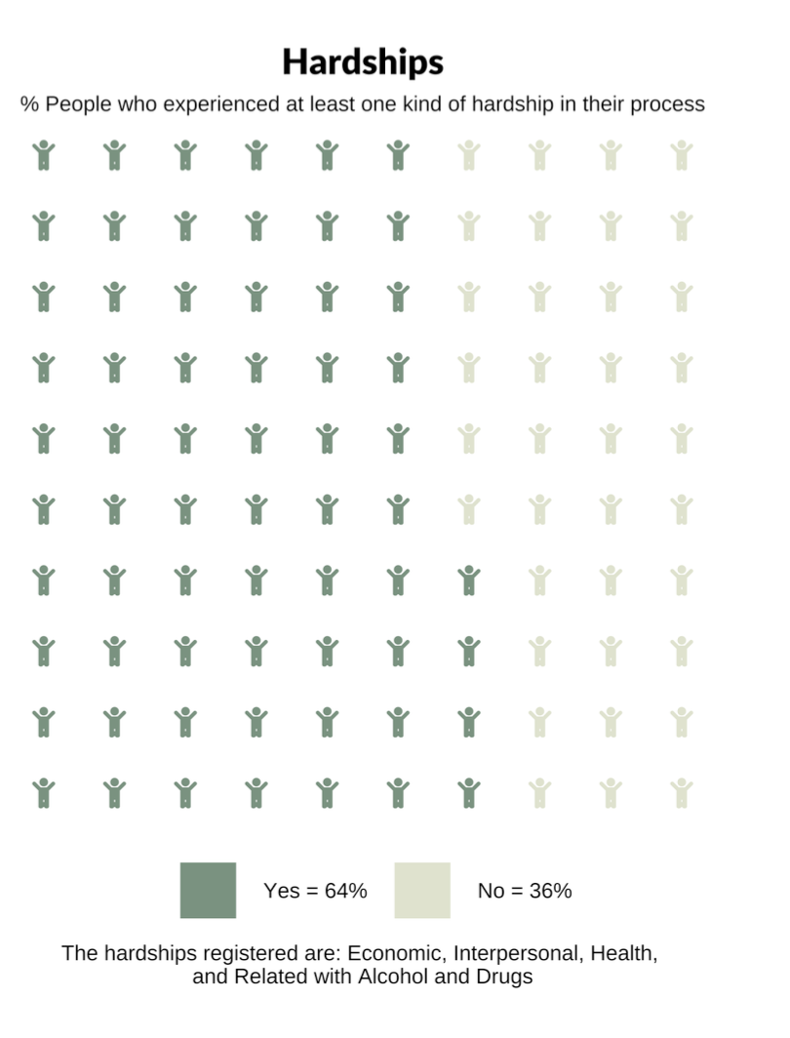

Figure 6: *Perceptions of Corruption and Trust in the Region*

Figure Changes: We combine trust in institutions and corruptions perceptions

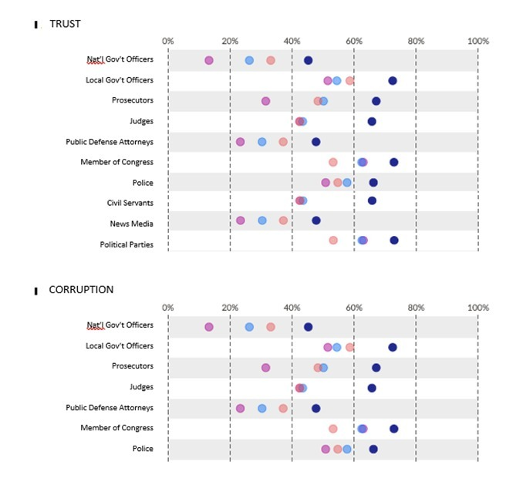

Figure 7: *Bribery Victimization in Colombia and Regional Peer Countries*

**Section 3: Security and Criminal Justice**

*Figure 8: Crime Victimization*

Figures Changes: Now the name of the final Sankey panel is “Prosecuted and Punished rate” not “Official Crime Report”.

*Figure 9: Security*

Figure 10: *Perceptions of the Criminal Justice System in Colombia*

Figure 11: *Corruption, Trust, Effectiveness of Criminal Justice Actors*

Figure 12: TRUST AND SAFETY

Figure Changes: We reorganized the police dashboard with the variables that we have as we show below:

*TRUST AND SAFETY*

* Trust the police
* Resolve security problems
* Perform effective and lawful investigations
* Available to help when needed
* Feel safe walking in their neighborhoods (we can include just the q9 reg label)

*ACCOUNTABILITY AND DUE PROCESS*

* Act lawfully
* Respect the rights of suspects
* Treat all people with respect
* Are not involved in corrupt practices
* Investigate crimes in an independent manner
* Are held accountable for violating the law

*DISCRIMINATION*

* We will use all the variables about discrimination bias of the police

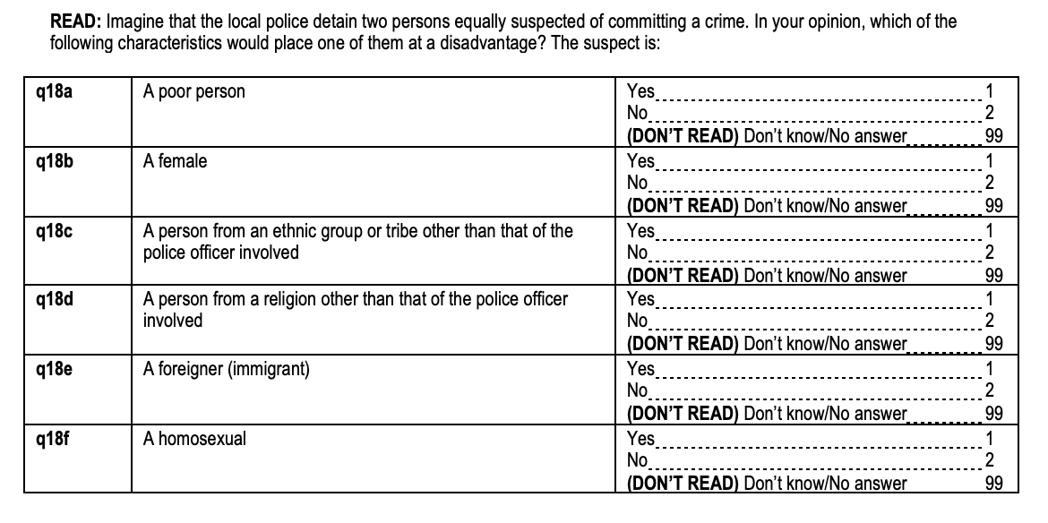

**Section 4: A2J**

Figure 13: *Justice Journey in Colombia*

1. Please adapt to local usage: Head of State, President, Prime Minister, or government, as applicable.